Firewall ----- Can filter the traffic, means which traffic do you want to allow and which traffic do you want to block.

**IP Tables**

Iptables is tool which is used to create quick and powerful firewall. It is used to manage packets incoming and outgoing from our system. By using iptables we can block or allows network traffic based on user defined conditions. It is used to manage Linux firewall roles.(simply learning)

If you want to drop the standard policy

#iptables -p FORWARD DROP

If you want to drop network from particular server

#iptables -A INPUT -s 192.168.0.23 -j DROP

If you want to drop the connection to all servers from particular network

#iptables -A INPUT -s 192.168.0.0./24 -p tcp –destination-port 25 -j DROP

If you want to accept only one server from out of dropped network

#iptables -A INPUT -s 192.168.0.66 -j ACCEPT

If you accept the network 192.168.0.66 also it will not connect, because top row will get the higher priority.

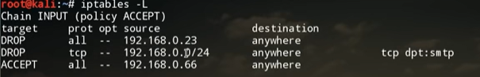

To delete a row

#iptables -D INPUT <Row number>

To add a row in top

#iptables -I INPUT -s 192.168.0.66 -j ACCEPT

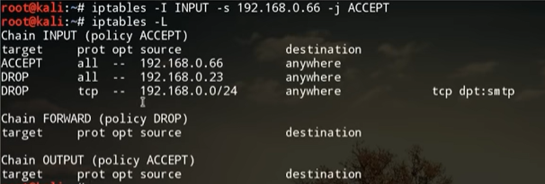

To check the content of different tables

#iptables -t <table name> -- list

We have filter, nat, mangle and pro tables

============================

To drop all incoming packets

#iptables -A INPUT -j DROP

To accept incoming packets

#iptables -A INPUT -j ACCEPT

To drop a packet from specific protocol

#iptables -A INPUT -p icmp -j DROP

To enable connections for protocol

#iptables -A INPUT -p tcp –dport 22 -j ACCEPT 🡺for ssh

#iptables -A INPUT -p tcp –dport 80 -j ACCEPT 🡺for http

#iptables -A INPUT -p tcp –dport 443 -j ACCEPT 🡺for https

#iptales -A INPUT -I etho -p tcp –dport 80 -j DROP 🡺 for particular interface

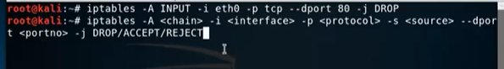

To accept limited packets



**Wget Command**

Wget is a command line utility used to download files from the web.

# wget <file url>

#wget -o <user definedname> <file url>

To download multipule files

#wget <url><space><url>

To download a particular directory

#wget -P <directory path> <url>

To resume the downloading file

#wget -c <directory path> <url>

To control the download speed

# wget –limit-rate=<specify the speed in mega bits> <url>

**Curl Command**

The curl is used to transfer data or checking website status.

#curl <url>

To redirect the output to another directory

#curl -o <file name> <url>

To download with default name

#curl -O <url>

To get the header’s only

#curl -I <url>

#curl <url>

Ping Command

The ping command checks whether the connection with a hostname is working or not. Send data packets to hosts.

To check the connectivity

#ping <ip address>

#ping <hostname>

For count

#ping -c 3 <ip address>

At the time of pinging will give time count

#ping -w <seconds> <ip address>

Telnet Command

If you want to check the connectivity to remote server, weather particular port is working or not

#telnet <remote IP> <port number>

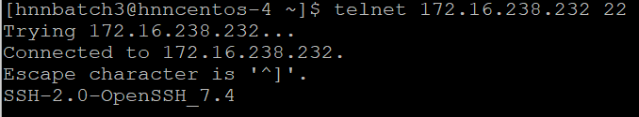

If you get above message the remote port is ready to listen

FTP

FTP is preferred protocol for sending and receiving large files. You can establish a ftp connection with a remote host and then use commands for uploading, downloading files, checking file and browsing them.

telnet

Telnet utility helps you to connect to a remote linux computer and works on it

SSH

SSH is a replacement for telnet and is used by system admin to control remote Linux servers.

Netstat

To see all the connections

#netstat -a

To see TCP connections

#netstat -at

To see UDP connections

#netstat -au

To see the listening ports

#netstat -l

To see the listening TCP connections

#netstat -lt

To see the listening UDP connections

#netstat -lu

To see the statistics

#netstat -s

To see the statistics for TCP

#netstat -st

To see the statistics for UDP

#netstat -su | less

To see the PID of all TCP connections

#netstat -pt |less

To see the PID of all UDP connections

#netstat -pu |less

To see the PID of all UNIX connections

#netstat -x |less

To see the numeric ports

#netstat -n

To see network statistics continuously

#netstat -c

To see the interfaces

#netstat -ie (ie—extend interface) the output of this same as #ifconfig

**TOP Command**

It will show the load average and CPU utilization

Every 3 seconds it will refresh, if you want to see every 5 seconds simply press “**s**”, it will ask you the time.

You want to filter press ”**i**” will show only running processes

If want to kill the process, press “**k**” and enter PID press enter

**Kill Command**

To see all running processes

#ps -ef | less

To see all the processes running in a particular user

#ps -U <username>

**Scripting**

Script is a text file that contains sequence of commands for Linux based OS.

#vi myscript.sh

#!/bin/bash

Echo”Hello”

Save file and execute

#./myscript.sh

Find

To find out the file

#find <PWD> -name <name of file>

#find <PWD> -mtime -2(no.of days back)

Cal (Calender)

#cal ---- week days will come on the top

#ncal ---week days come on the left

#cal 2020 --- will show calendar month

#cal 2 2020 --- show month